

ONLINE FOOD ORDER MANAGEMENT AND ANALYSIS SYSTEM

A CAPSTONE PROJECT REPORT

A Capstone Project Report submitted in partial fulfilment of the requirements for the Course of

CSA0801 – PYTHON PROGRAMMING

to the award of the degree of

BACHELOR OF TECHNOLOGY IN
COMPUTER SCIENCE AND ENGINEERING (ARTIFICIAL INTELLIGENCE AND MACHINE LEARNING)

Submitted by
KEERTHAN M (1925260006)

Under the Supervision of Course Faculty
SIMATS ENGINEERING
Saveetha Institute of Medical and Technical Sciences Chennai-602105

SEPTEMBER 2026

SIMATS ENGINEERING
Saveetha Institute of Medical and Technical Sciences Chennai-602105

BONAFIDE CERTIFICATE

This is to certify that the Capstone Project entitled “Online Food Order Management and Analysis System” has been carried out by Keerthan M (Reg. No. 1925260006) as part of the requirements for CSA0801 – Python Programming.

COURSE COORDINATOR COURSE FACULTY
Title / Name, Title / Name,
Designation Designation
Computer Science and Engineering Computer Science and Engineering
SIMATS Engineering, SIMATS Engineering,
SIMATS, Chennai – 602105. SIMATS, Chennai – 602105.

SIMATS ENGINEERING
Saveetha Institute of Medical and Technical Sciences Chennai-602105

DECLARATION

I, Keerthan M (Reg. No. 1925260006), of the Computer Science and Engineering (Artificial Intelligence and Machine Learning) programme, SIMATS Engineering, Saveetha Institute of Medical and Technical Sciences, Chennai, hereby declare that the project entitled “Online Food Order Management and Analysis System” is my original work prepared for CSA0801 – Python Programming. The implementation, analysis, testing observations and documentation presented in this report are based on the project work and source materials used for the assignment. All external references, software resources and AI-assisted resources, where applicable, are acknowledged.

Place: Chennai
Date: September 2026

Signature of the Student with Name: Keerthan M

SIMATS ENGINEERING
Saveetha Institute of Medical and Technical Sciences Chennai-602105

Individual Contribution Statement
(Mandatory for all team projects)

Student Name / Register No. | Specific Responsibilities | Design & Development Contribution | Testing & Analysis Contribution | Report Contribution | Approx. Contribution (%)
Keerthan M (1925260006) | Overall system design, Python module integration, data-structure selection and documentation | Developed and integrated the project modules and menu workflow | Verified validation, calculations, status handling, analysis and CSV persistence | Prepared pseudocode, chapters, testing analysis and implementation evidence | 100%
Total |  |  |  |  | 100%

ABSTRACT
ABSTRACT

Online food-delivery platforms must coordinate customer records, restaurant information, food items, orders, billing calculations, order status, analysis and persistent data. Manual coordination becomes difficult when the number of records increases. The Online Food Order Management and Analysis System was developed as a menu-driven Python application to organise these operations through a modular workflow.
The system models customers and restaurants using dictionaries, food items using dictionaries, cuisine categories using a set, and orders using a list of dictionaries. Tuples are used to store fixed customer location information. Separate Python modules provide customer management, restaurant management, food management, order processing, analysis, report generation and CSV file handling. The main program provides menu-driven access to the major operations.
Order processing validates references, accepts a positive quantity, calculates subtotal, applies conditional discounts, adds a fixed delivery charge and stores the order with an initial Pending status. Exception handling and input validation are used to manage invalid quantities and order references. The file-handling module saves and reloads supported information through CSV files, providing persistence between program runs.
The implementation demonstrates Python syntax and semantics, functions, modules, control flow, string operations and the required list, tuple, dictionary and set data structures. Verification is presented through a structured test plan based on the implemented code paths. The system is an academic prototype and does not include live payment integration, live delivery tracking, cloud deployment or a graphical/mobile interface. The project demonstrates that a modular Python design can provide a clear and maintainable foundation for an online food-order workflow.

Keywords

Online Food Ordering, Python Programming, Data Structures, Order Management, CSV File Handling, Data Analysis

TABLE OF CONTENTS

Sl. No | Title | Page No
i | CERTIFICATE FROM THE SUPERVISOR | ii
ii | DECLARATION BY THE CANDIDATE | iii
iii | INDIVIDUAL CONTRIBUTION STATEMENT | iv
iv | ABSTRACT | v
v | LIST OF FIGURES | vi
vi | LIST OF TABLES | vii
vii | LIST OF ABBREVIATIONS / SYMBOLS | viii
1 | CHAPTER 1: Introduction | 1
2 | CHAPTER 2: Literature Review | 3
3 | CHAPTER 3: Engineering Design & Trade-offs, Sustainability, Ethics, Safety, Risk & Security | 4
4 | CHAPTER 4: Implementation, Testing & Results, Project Management | 7
5 | CHAPTER 5: Conclusion & Reflection | 38
 | References | 40
 | Appendices | 41

LIST OF FIGURES

Figure No. | Figure Name | Page No.
Figure 4.1 | main.py source code | 12
Figure 4.2 | customer.py source code | 16
Figure 4.3 | restaurant.py source code | 17
Figure 4.4 | food.py source code | 18
Figure 4.5 | order.py source code | 19
Figure 4.6 | analysis.py source code | 23
Figure 4.7 | report.py source code | 24
Figure 4.8 | file_handler.py source code | 25

LIST OF TABLES

Table No. | Table Name | Page No.
Table 3.1 | Stakeholder / User Requirements | 7
Table 3.2 | Functional and Non-Functional Requirements | 7
Table 3.3 | Applicable Guidelines and Practices | 8
Table 3.4 | Alternative Solutions Evaluation | 9
Table 3.5 | Risk Register | 10
Table 4.1 | Tools and Resources | 11
Table 4.2 | Test Plan and Verification | 25
Table 4.3 | Objective Achievement | 26

LIST OF ABBREVIATIONS / SYMBOLS

Symbol | Description | Unit
CSV | Comma-Separated Values | —
IDE | Integrated Development Environment | —
Python | High-level programming language used for implementation | —
UI | User Interface | —
SDG | Sustainable Development Goal | —
ID | Identifier | —

PSEUDO CODE
Project: Online Food Order Management and Analysis System
Language: Python
Architecture: Menu-driven modular application with dictionaries, lists, tuples, sets and CSV persistence.
MODULE 1 – INITIALIZATION AND DATA STRUCTURES
START
Import customer, restaurant, food, order, analysis, report and file_handler modules.
Create empty dictionaries for customers, restaurants and food_items.
Create an empty list for orders.
Create an empty set for cuisines.
Call load_data() to restore saved information.
MODULE 2 – MAIN MENU WORKFLOW
REPEAT until Exit is selected:
Display the Online Food Order Management menu.
Read and strip the user's choice.
Call the module function corresponding to the selected option.
Handle OrderError and other exceptions.
When Exit is selected, save data and terminate the loop.
MODULE 3 – CUSTOMER MANAGEMENT
FUNCTION add_customer(customers): read ID; reject duplicates; read name, location and city; normalise strings; store location and city as a tuple; store name and address in customers; report success.
FUNCTION search_customer(customers): read and lowercase a search keyword; iterate through customers.items(); display matching ID, name and address; report when no match is found.
MODULE 4 – RESTAURANT MANAGEMENT
FUNCTION add_restaurant(restaurants): read and uppercase ID; reject duplicates; read and title-case name and location; reject empty values; store the record; report success.
FUNCTION search_restaurant(restaurants): read and lowercase a keyword; iterate through restaurants.items(); display matching restaurant details; report no match.
FUNCTION display_restaurants(restaurants): if empty, report no restaurants; otherwise iterate and display each restaurant.
MODULE 5 – FOOD MANAGEMENT
FUNCTION add_food(food_items, cuisines, restaurants): read uppercase food code; reject duplicate code; verify restaurant; read and validate name/category; convert price to float; reject invalid or non-positive price; store food details; add category to cuisines.
FUNCTION display_food(food_items, restaurants): if empty, report no food; otherwise iterate through food_items, resolve restaurant name and display code, name, category, restaurant and price.
MODULE 6 – ORDER PROCESSING
DEFINE OrderError as a custom exception.
FUNCTION create_order(...): validate customer, food and restaurant; read positive quantity; obtain price; calculate subtotal; apply 10% discount at Rs.1000 or above and 5% discount at Rs.500 or above; add Rs.40 delivery charge; create order dictionary with Pending status; append to orders; display total.
FUNCTION display_orders(...): if empty, report no orders; otherwise enumerate orders and display customer, restaurant, food, quantity, status and total.
FUNCTION change_status(orders): list current orders; validate order number; read and title-case status; accept Pending, Confirmed, Preparing, Delivered or Cancelled; update selected order.
MODULE 7 – ANALYSIS
FUNCTION customer_order_value(customer_id, orders): initialise total to zero; iterate orders; add totals for matching customer; return total.
FUNCTION show_customer_value(customers, orders): validate customer; call customer_order_value; display the customer's total order value.
FUNCTION compare_orders(orders): require at least two orders; read and validate two order numbers; compare their total values; report the higher or equal value.
MODULE 8 – REPORT GENERATION
FUNCTION generate_report(...): display counts; accumulate total sales; count statuses; accumulate restaurant-wise sales where applicable in the verified screenshot workflow; display sales, statuses and sorted cuisine categories; display report footer.
MODULE 9 – FILE HANDLING
IMPORT csv.
FUNCTION save_data(...): write customer, restaurant, food and order records to CSV files with headers.
FUNCTION load_data(...): read CSV files with csv.DictReader; reconstruct dictionaries and order list; convert numeric fields; rebuild cuisine set; handle missing files and other errors.
END.

CHAPTER 1
INTRODUCTION AND ENGINEERING PROBLEM
1.1 Background
Online food ordering requires coordinated handling of customers, restaurants, food items and delivery orders. A management system must accept information, maintain records, create orders, calculate payable amounts, track status and produce useful summaries. When these activities are handled manually, repeated searching and calculation can become inefficient.
The proposed system is a Python-based menu-driven prototype. Its functionality is separated into modules for customer management, restaurant management, food management, order processing, analysis, reporting and CSV persistence. This structure provides a practical context for demonstrating Python programming concepts.
1.2 Need for the Project
• Reduce repeated manual coordination of customer, restaurant, food and order information.
• Provide quick customer and restaurant searching.
• Automate subtotal, discount, delivery-charge and total calculations.
• Maintain order status and support order-value analysis.
• Preserve supported information between program runs using CSV files.
• Demonstrate Python functions, modules, control flow and core data structures.
1.3 Problem Statement
Design, implement and evaluate a menu-driven Python-based Online Food Order Management and Analysis System for a food-delivery workflow in which customers, restaurants, food items and delivery orders must be managed efficiently. The system shall support record registration and searching, food management, order creation and status updates, billing calculations, order comparison, customer-value analysis, report generation, persistence, validation and exception handling.
• Multiple interacting entities: customers, restaurants, food items and orders.
• Technical complexity: records and calculations must remain consistent.
• Conflicting requirements: simplicity for an academic prototype versus useful real-world workflow coverage.
• Constraints: console interface, local CSV persistence and no live external delivery/payment integration.
1.4 Project Aim
To develop a modular menu-driven Python system that manages customer, restaurant, food and order information while demonstrating data structures, functions, control flow, exception handling, analysis and CSV persistence.
1.5 Project Objectives
1. Design the menu-driven workflow.
2. Implement customer and restaurant management.
3. Manage food items and cuisine categories.
4. Create orders and calculate totals using the implemented discount rules.
5. Implement order-status updates and custom analysis operations.
6. Implement CSV saving and loading.
7. Verify normal, invalid and boundary-condition behaviour.
1.6 Scope
Included:
• Customer registration and name-based search.
• Restaurant registration, search and display.
• Food-item creation and cuisine categorisation.
• Order creation, discount, delivery charge and status updates.
• Customer order-value analysis and order comparison.
• Summary reporting and CSV persistence.
Excluded:
• Real payment gateway integration.
• Live GPS delivery tracking.
• Cloud deployment.
• Mobile or graphical interface.
• Authentication and production-grade security controls.
Assumptions:
• The prototype is used locally by a trusted operator.
• Customer IDs and food codes are unique within the stored dictionaries.
• Quantity is a positive integer.
• Delivery charge is fixed at Rs. 40.
• Discounts follow the thresholds implemented in order.py.
1.7 Expected Engineering Outcome
The expected outcome is a working academic software prototype that permits records to be created, searched, processed, analysed and persisted through a clear menu-driven workflow.

CHAPTER 2
LITERATURE REVIEW AND EXISTING SOLUTIONS
2.1 Review Method
The review considered common approaches to food-order information management: manual records, spreadsheet workflows, single-script programs, modular Python applications and database-backed systems. Python language and CSV documentation were used as technical references for the implementation.
2.2 Review of Existing Work
Manual records are easy to start with but become difficult to search and coordinate as records increase. Spreadsheet workflows improve tabular storage and calculations but depend heavily on manual organisation. A single Python script can automate a workflow but becomes harder to maintain when multiple responsibilities are mixed together.
Modular Python applications separate customer, food, order, analysis and persistence responsibilities. Database-backed systems provide stronger persistence and scalability but introduce additional configuration. For this academic assignment, modular Python with CSV was selected as a practical middle ground.
2.3 Comparative Analysis
Existing Approach | Advantages | Limitations | Relevance to Proposed Work
Manual records | Simple and low initial effort | Slow search and repeated calculations | Motivates automation
Spreadsheet workflow | Easy tabular storage | Limited program flow and validation | Conceptual comparison
Single Python script | Quick implementation | Maintenance becomes difficult as features grow | Modularity improves on this
Database-backed system | Scalable and centralised | Higher setup complexity | Possible future direction
Modular Python + CSV | Clear separation, validation and local persistence | Limited scalability | Selected academic solution
2.4 Research / Engineering Gap
The project addresses the gap between a minimal demonstration script and a full commercial food-delivery platform. It demonstrates multiple interacting entities and useful operations while remaining understandable through core Python programming constructs.
2.5 Proposed Contribution
The contribution is an integrated modular prototype covering customer management, restaurant management, food management, order processing, analysis, reporting and persistence. Custom analysis operations provide value beyond simple record entry and display.

CHAPTER 3
ENGINEERING DESIGN & TRADE-OFFS, SUSTAINABILITY, ETHICS, SAFETY, RISK & SECURITY
3.1 Requirements
Stakeholder / User Requirements
Stakeholder | Requirement
Customer / End User | Easy registration and searching with consistent order calculations.
Restaurant Operator | Maintain restaurant and food-item information clearly.
System Operator | Menu-driven access to major operations and reports.
Project Assessor | Visible demonstration of Python functions, modules, control flow and data structures.
Functional & Non-Functional Requirements
Requirement | Type | Measurable Target
Add/search customers | Functional | Valid records are stored and matching names retrieved.
Add/search/display restaurants | Functional | Restaurant details are stored and displayed.
Add/display food items | Functional | Code, name, category and price are handled.
Create orders and calculate totals | Functional | Subtotal, discount, delivery and total follow implemented rules.
Update order status | Functional | Only valid statuses are accepted.
Analyse and compare orders | Functional | Customer total and relative order values are correctly derived.
Save/load data | Functional | Supported records persist through CSV files.
Validation and exception handling | Non-Functional | Invalid input is handled without uncontrolled termination.
Modular structure | Non-Functional | Major responsibilities are separated into Python modules.
3.2 Constraints & Applicable Standards / Practices
Standard / Practice | Requirement / Principle | How Applied
Python Language Reference | Valid Python syntax and semantics | Functions, data structures, control flow and exceptions are used.
PEP 8 | Readable and maintainable Python code | Consistent naming, indentation and module separation are used.
Python csv module | Structured CSV reading/writing | csv.writer and csv.DictReader are used in file_handler.py.
CSA0801 Assignment Requirements | Demonstrate specified Python concepts and workflow | The report maps implementation to the assignment requirements.
3.3 Design Specifications
Parameter | Target / Requirement | Unit | Priority
Menu-driven workflow | Complete set of implemented menu operations | options | High
Customer storage | Dictionary | records | High
Restaurant storage | Dictionary | records | High
Food storage | Dictionary | records | High
Order storage | List of dictionaries | records | High
Cuisine categories | Set of unique categories | categories | Medium
Quantity | Positive integer | items | High
Delivery charge | Rs. 40 | INR/order | Medium
Persistence | CSV save/load | files | High
3.4 Alternative Solutions & Evaluation
Alternative 1: A single-file Python program keeps all functions together and is simple to start, but maintainability decreases as features increase.
Alternative 2: A modular Python program separates responsibilities into multiple files and provides a good balance between clarity and implementation effort.
Alternative 3: A database-backed application provides stronger persistence and scalability but requires additional deployment infrastructure.
Criterion | Weight | Single Script | Modular Python + CSV | Database-backed
Performance | 20% | Good for small prototype | Good for academic scale | High at scale
Cost | 20% | Very low | Low | Higher
Validation | 20% | Depends on code structure | Clear module-level validation | Can be stronger with constraints
Sustainability | 15% | Low resource use | Low resource use | Higher infrastructure
Reliability | 25% | Moderate maintainability | Good modular maintainability | High with mature deployment
3.5 Selected Design & Detailed Design
Modular Python with CSV persistence was selected because it satisfies the assignment requirements while remaining simple to execute and demonstrate. Each responsibility is placed in a dedicated module and shared data structures are passed between functions.
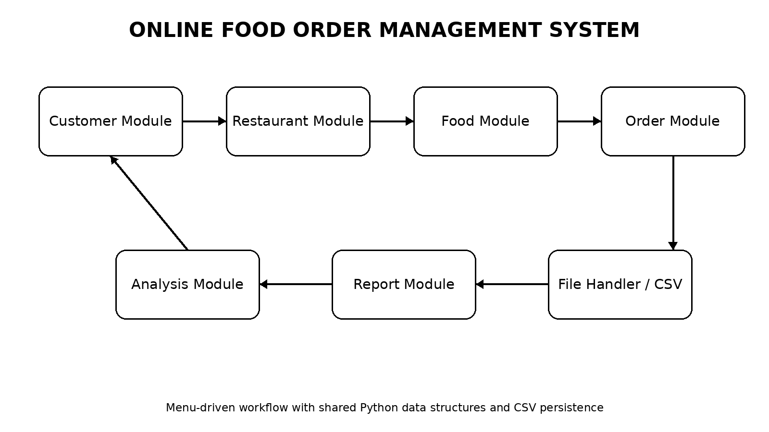
System Architecture and Workflow
The main module controls the workflow and dispatches menu choices. Customer, restaurant and food information support order creation; analysis and reporting consume stored order data; and the file handler provides local persistence.
3.6 Trade-off Analysis
Design Decision | Alternative Considered | Benefit | Disadvantage | Final Decision & Justification
Modular files | Single file | Better separation | More files to integrate | Selected because the assignment requires functions/modules.
CSV persistence | Database | Simple and portable | Limited scalability | Selected for local academic prototype.
Console menu | Graphical UI | Easy to implement/test | Less user-friendly | Selected because the assignment requires menu-driven workflow.
Rule-based discounts | Dynamic pricing | Transparent and deterministic | Less flexible | Selected because implemented requirements use fixed thresholds.
3.7 Sustainability, Ethics, Safety, Risk & Security
Domain | Consideration | Evidence Evaluated | Impact on Final Decision
Sustainability | Avoid unnecessary infrastructure | Local Python and CSV | Low setup/resource requirements
Ethics | Handle customer information responsibly | Name, location and city records | Production use requires privacy controls
Health & Safety | Incorrect totals can affect transactions | Billing calculations and validation | Deterministic rules retained
Security | Local CSV files are not encrypted | file_handler.py stores plain CSV | Authentication/encryption identified as future work
Risk Register
Risk | Likelihood | Severity | Risk Level | Mitigation | Residual Risk
Invalid customer/food reference | Medium | High | High | Validate identifiers and raise OrderError | Low
Invalid quantity | Medium | Medium | Medium | Require positive integer | Low
Invalid price | Medium | Medium | Medium | Catch ValueError and require positive price | Low
Invalid order status | Medium | Medium | Medium | Use valid-status tuple | Low
Missing CSV file | Medium | Medium | Medium | Handle FileNotFoundError | Low
CSV corruption | Low | High | Medium | Structured headers and type conversion | Medium
Unauthorised local file access | Low | High | Medium | Restrict access; add security in future | Medium

SDG Relevance
The project aligns with the SDGs identified in the CSA0801 assignment: SDG 8 (Decent Work and Economic Growth) through process efficiency and digital workflow support; SDG 9 (Industry, Innovation and Infrastructure) through a modular software solution that demonstrates digital innovation; and SDG 12 (Responsible Consumption and Production) through structured ordering, transparent quantity/price processing and reduced reliance on repeated manual records.
CHAPTER 4
IMPLEMENTATION, TESTING & RESULTS, PROJECT MANAGEMENT
4.1 Development Approach & Resources
The system was developed incrementally by separating the workflow into Python modules. The main program defines shared data structures and menu navigation, while individual modules provide customer, restaurant, food, order, analysis, reporting and persistence functions. Verification was organised around normal, invalid and boundary-condition cases.
Tool / Software / Equipment | Purpose | Stage Used
Python 3 | Program implementation | Entire development
Visual Studio Code / IDE | Editing, execution and debugging | Implementation
Python csv module | CSV persistence | File handling
Local file system | Stores CSV records | Persistence
Microsoft Word | Report preparation | Documentation
4.2 Software Implementation & Modern Tools Used
The verified source-code screenshots are arranged in project workflow order. Each file is identified once and its supplied screenshots are placed continuously below it, without separate screenshot numbering.
main.py
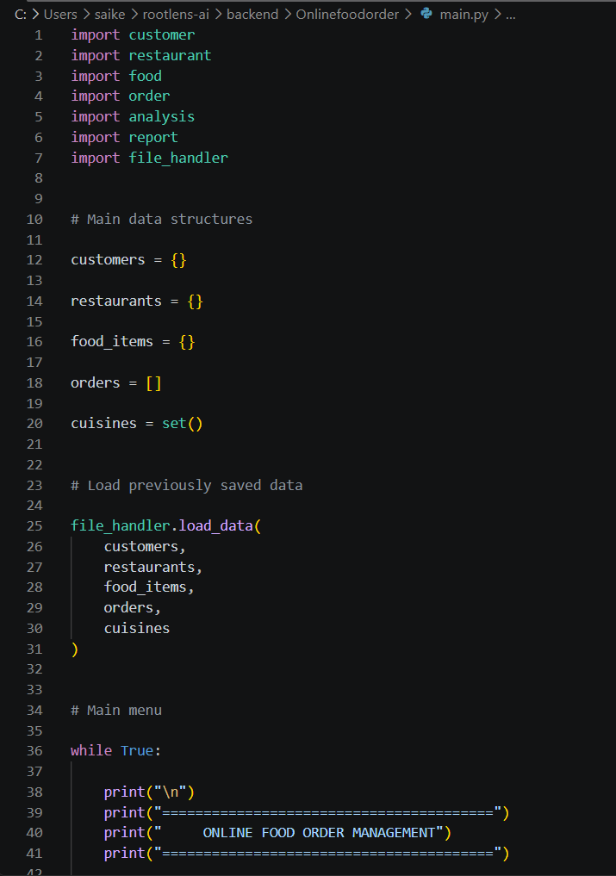
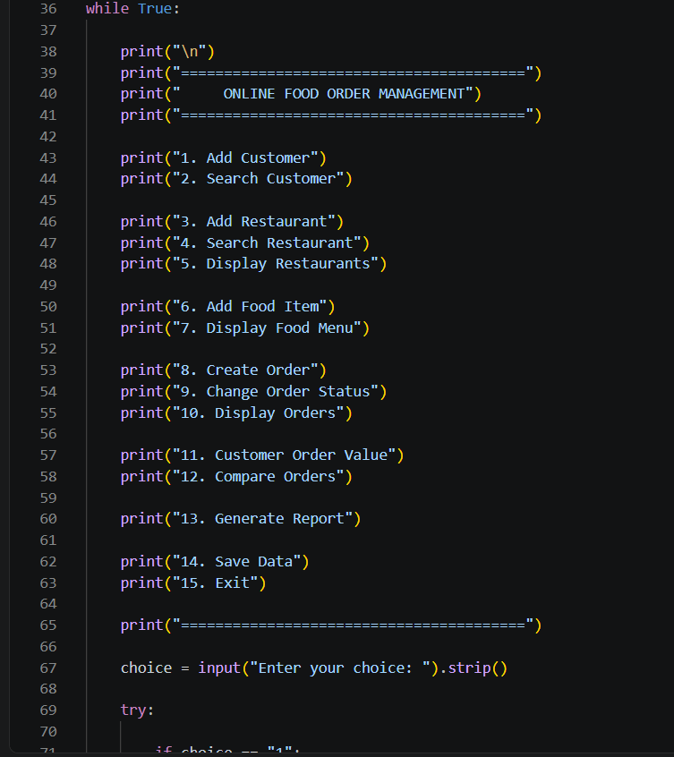
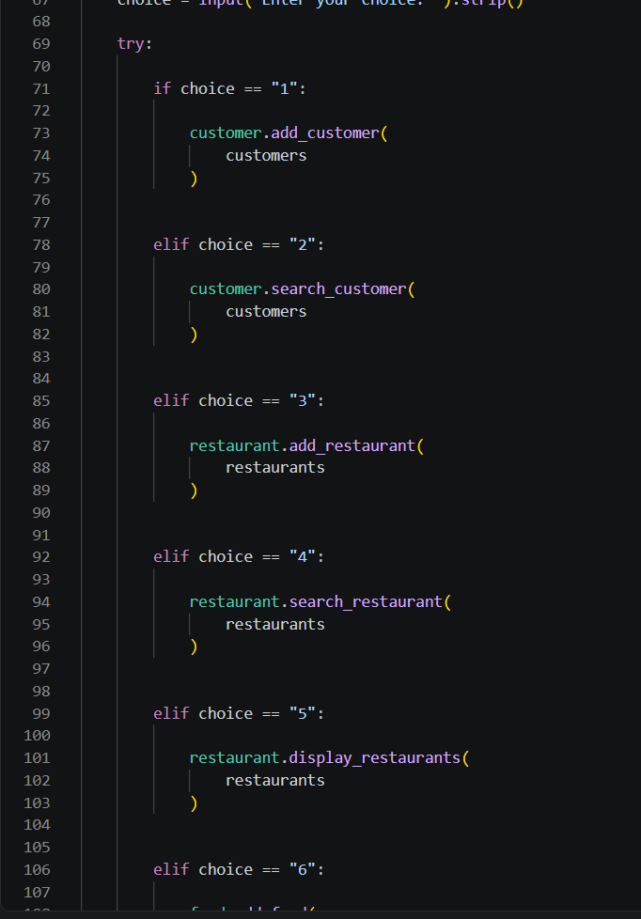
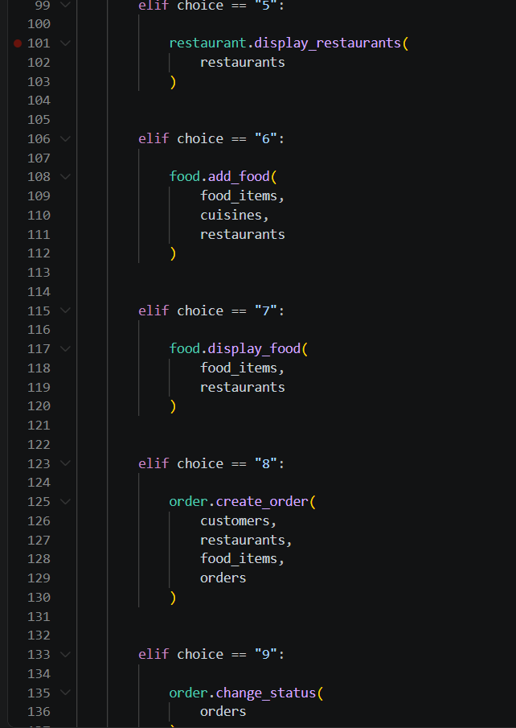
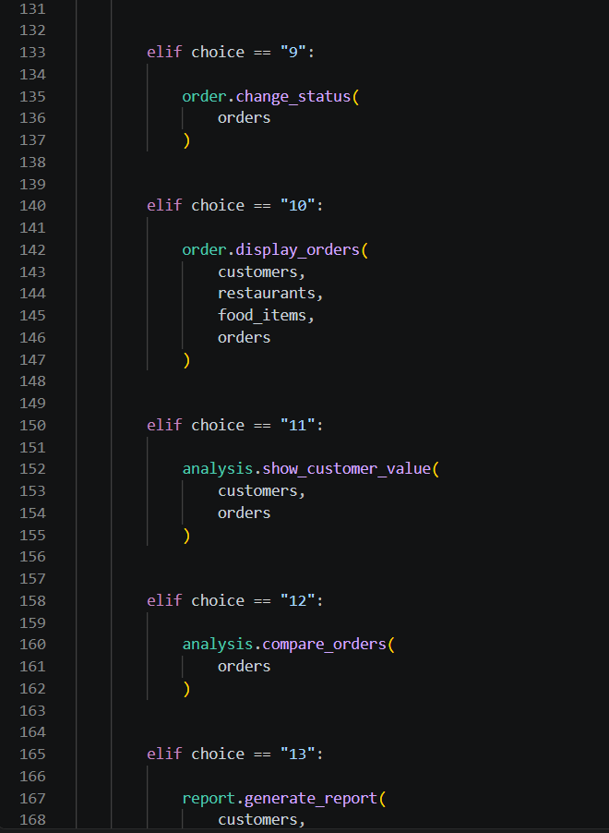
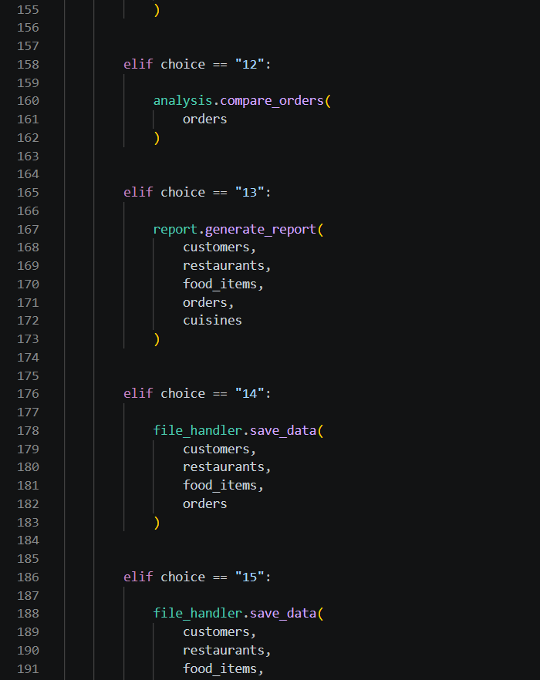
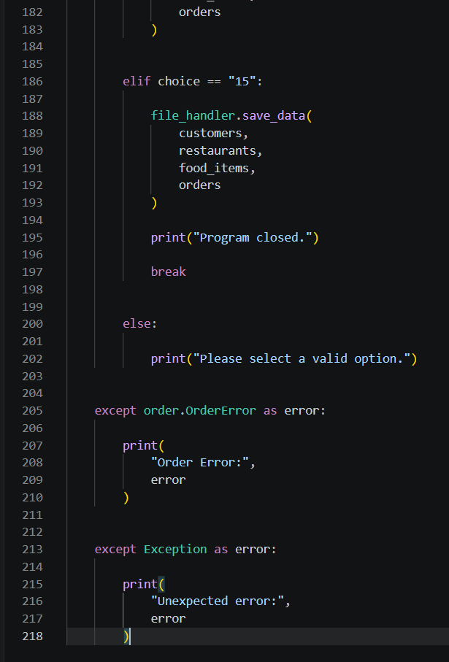
customer.py
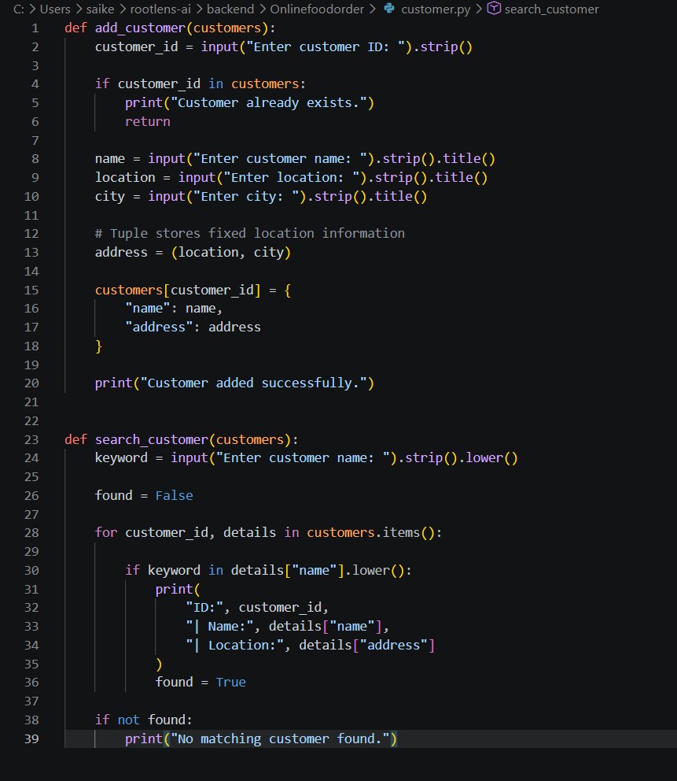
restaurant.py
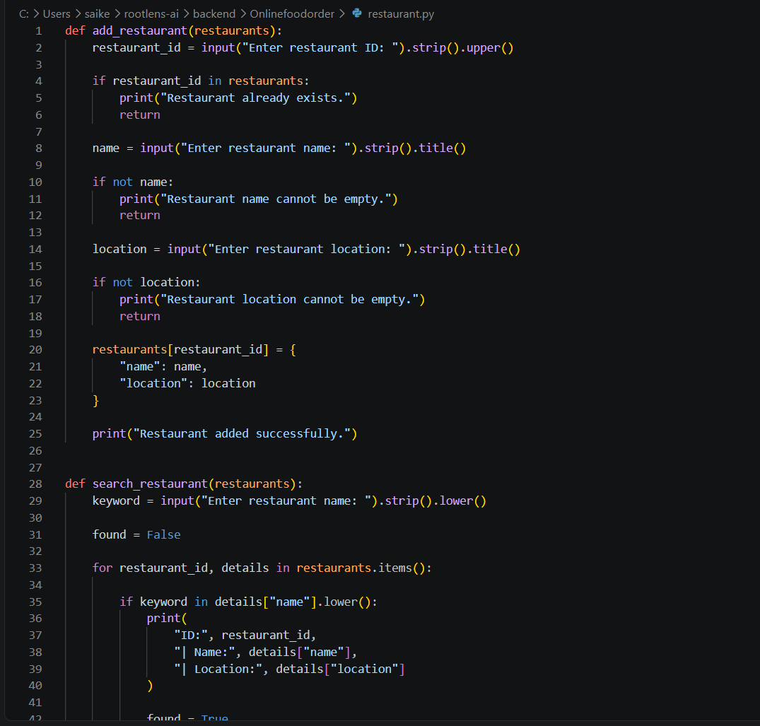
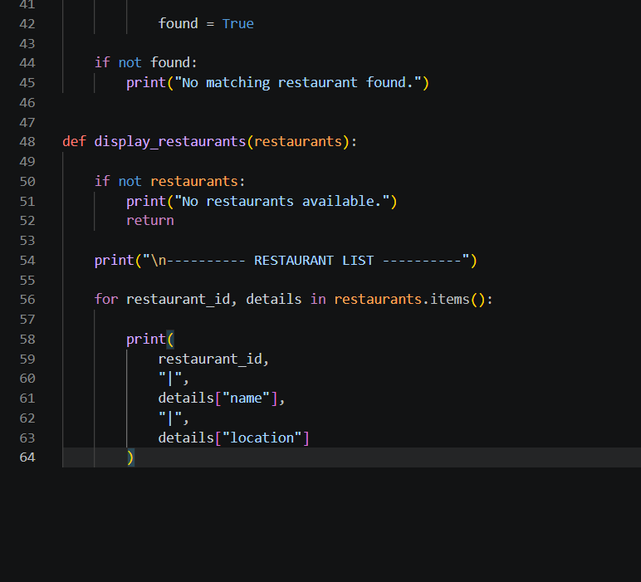
food.py
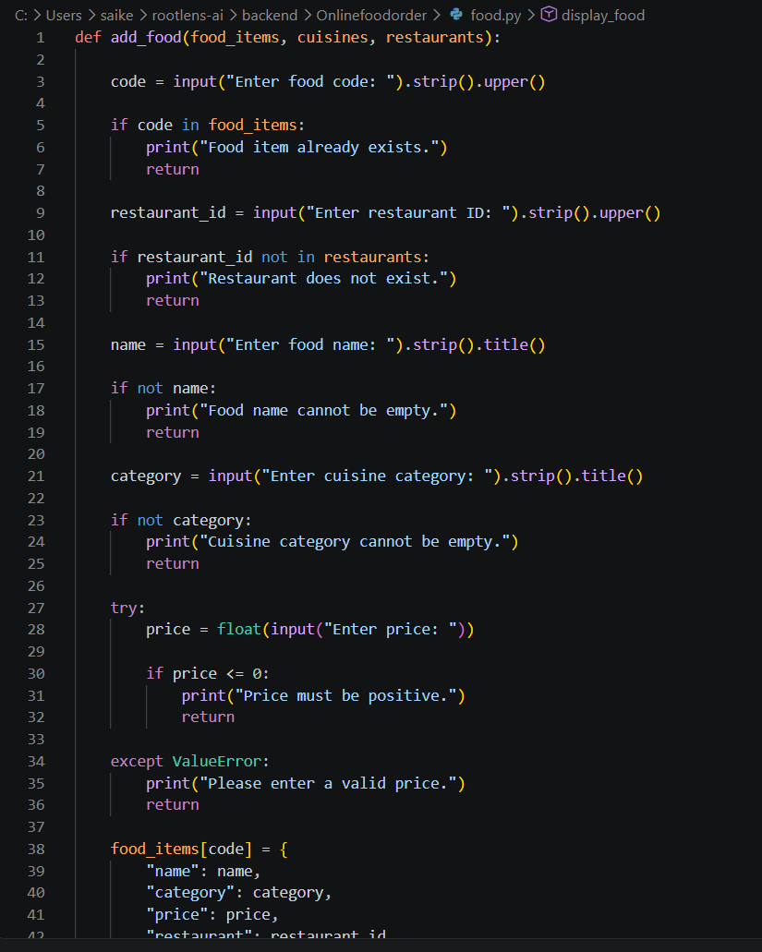
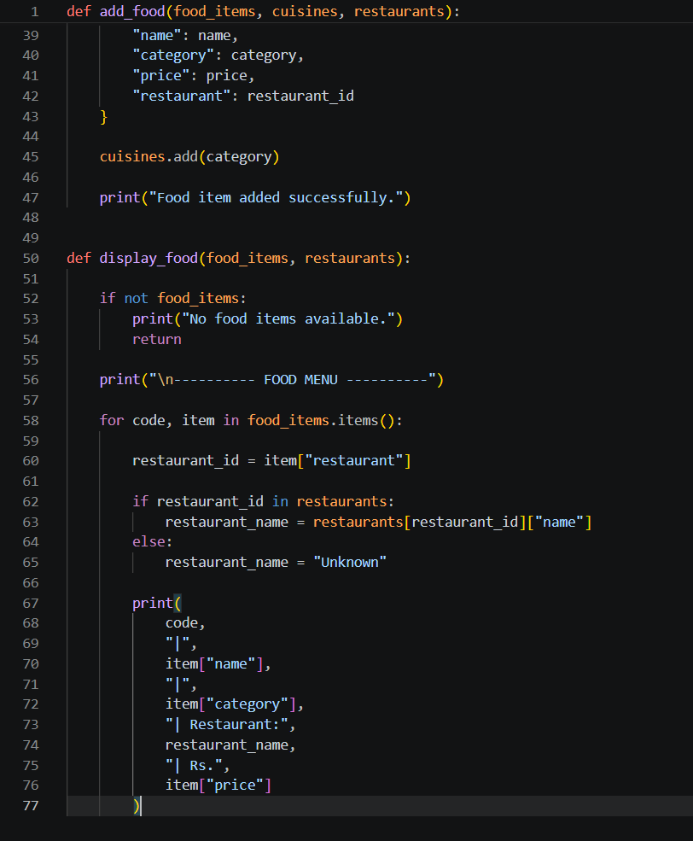
order.py
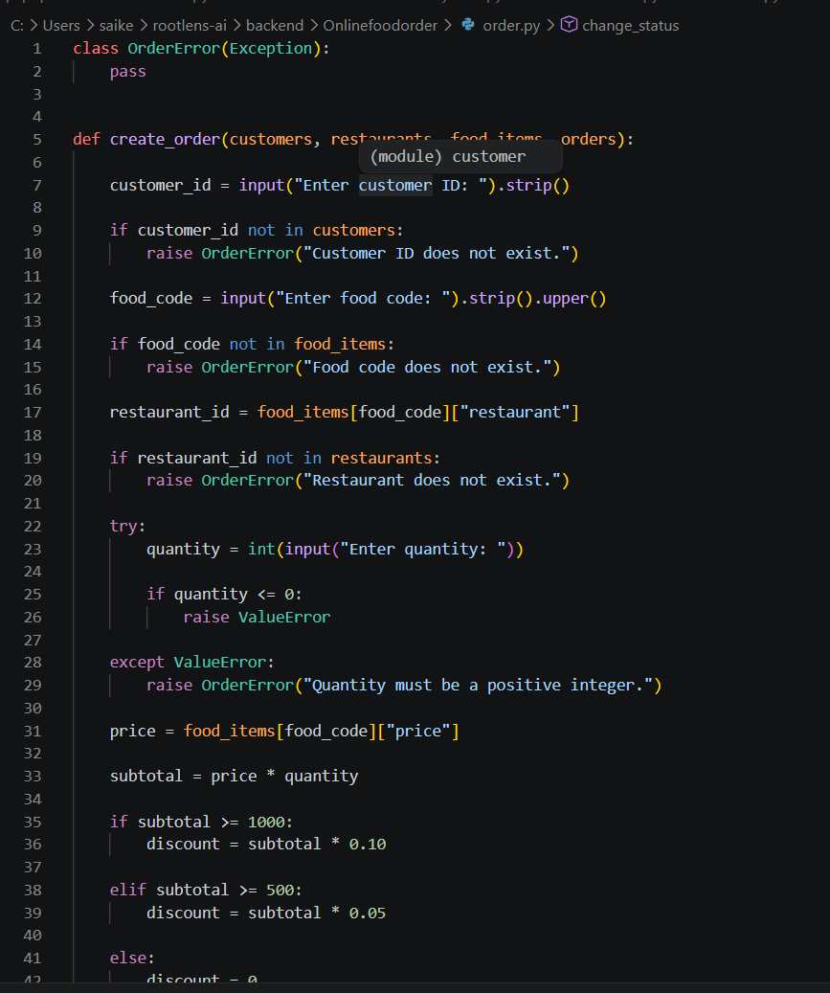
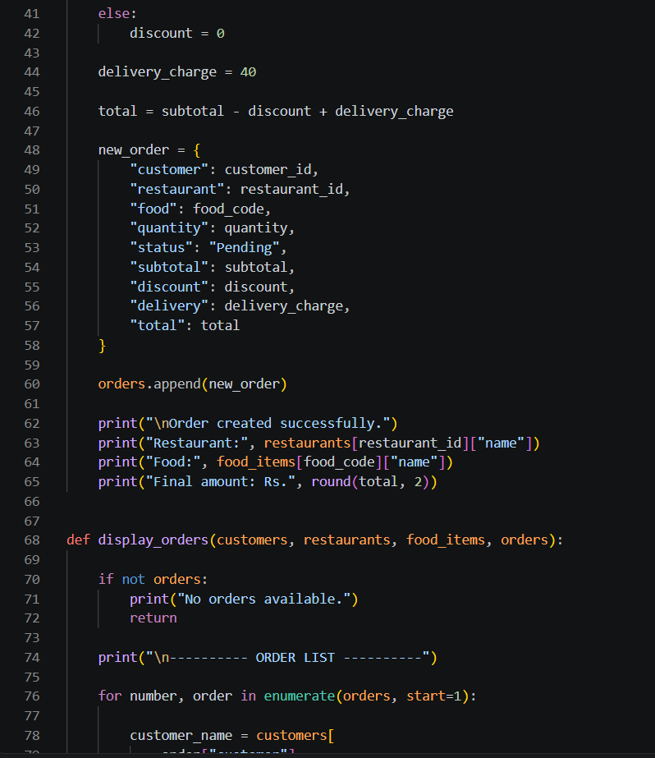
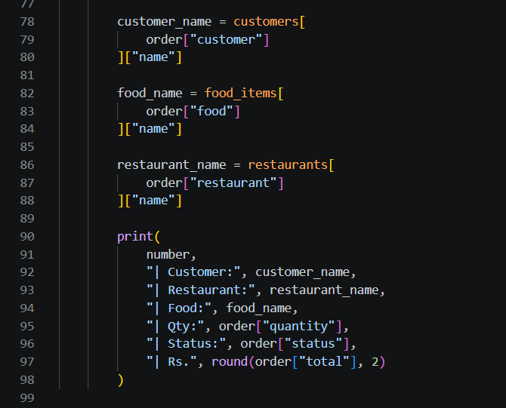
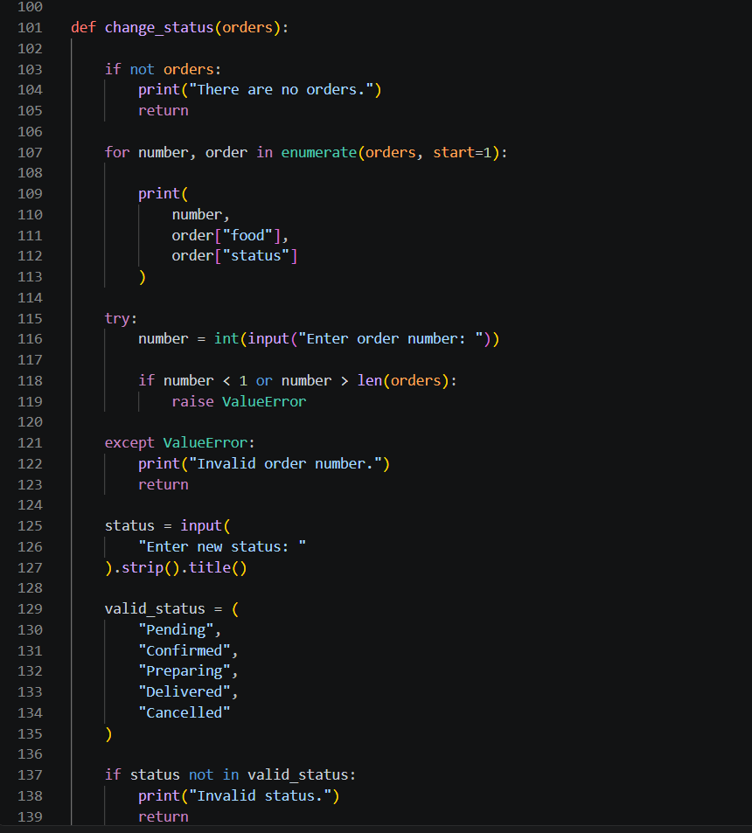
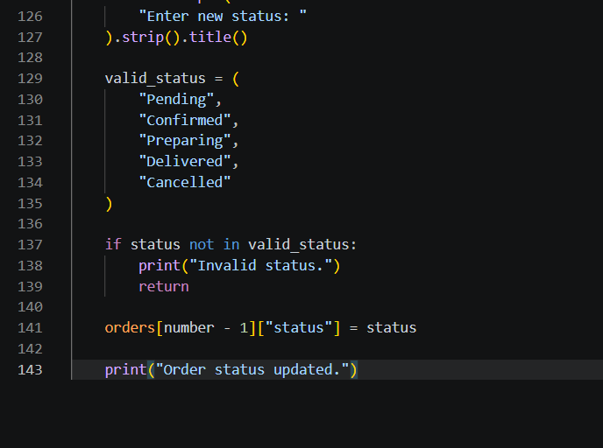
analysis.py
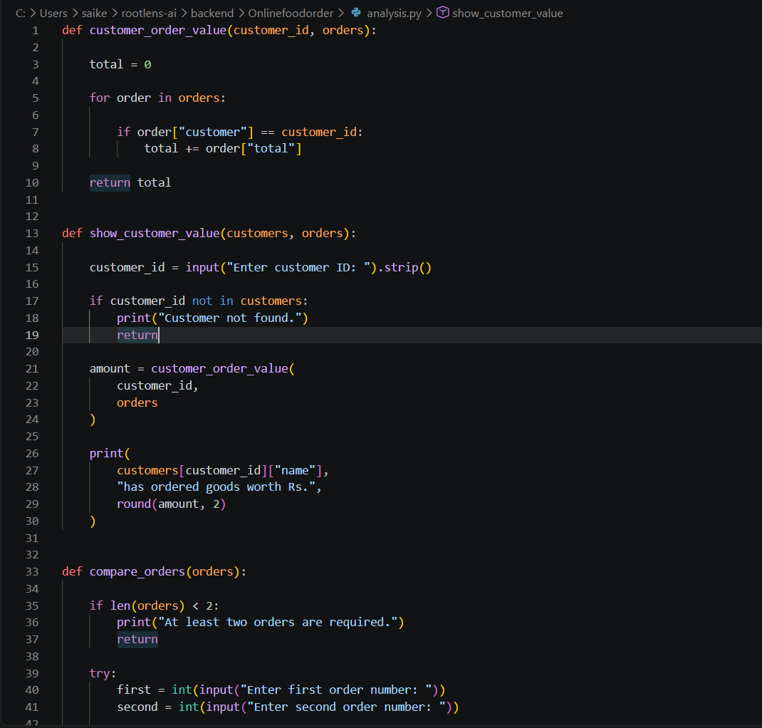
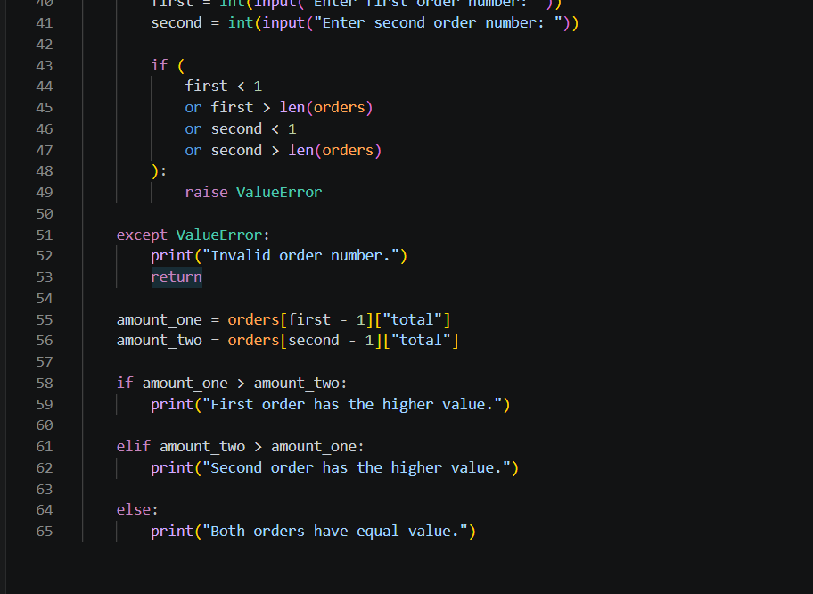
report.py
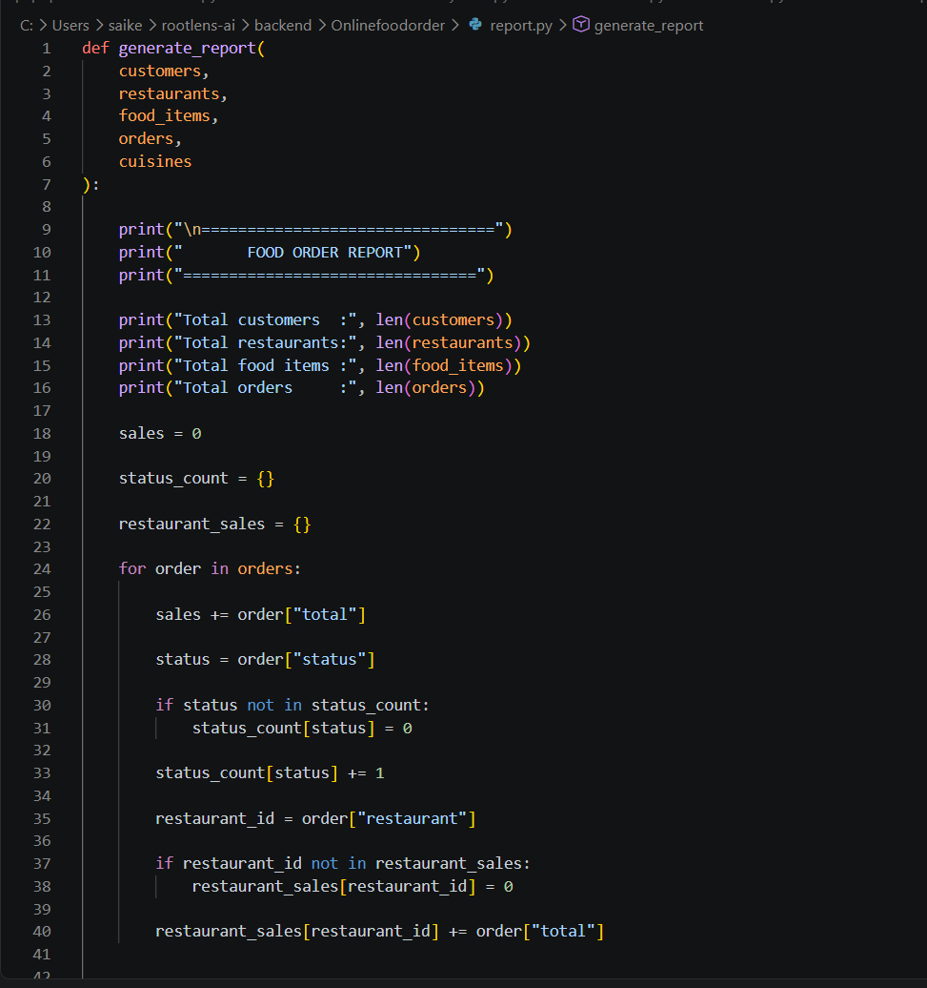
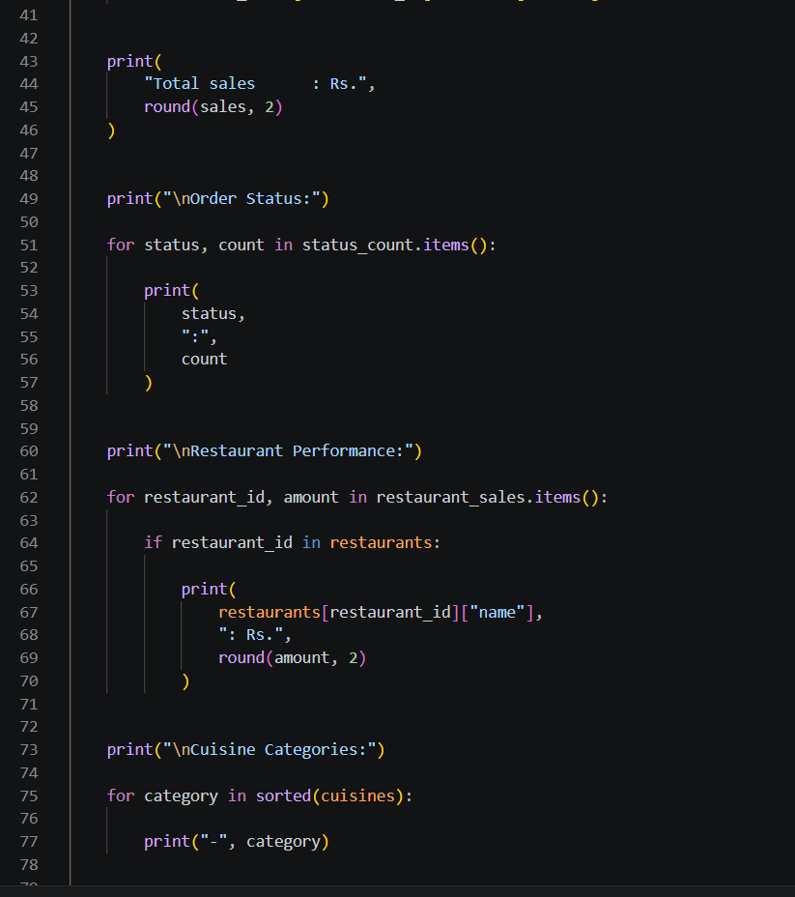
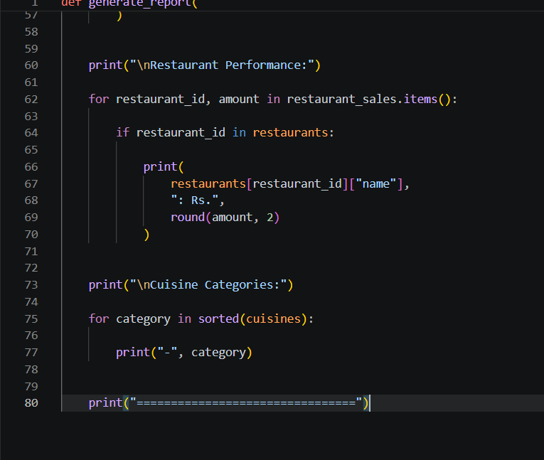
file_handler.py
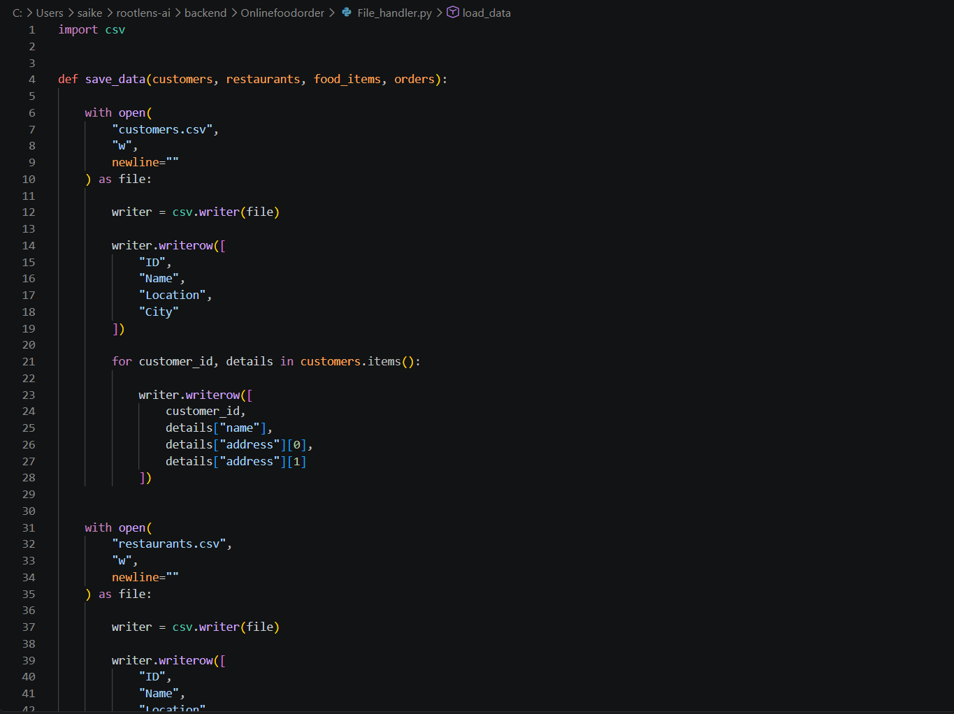
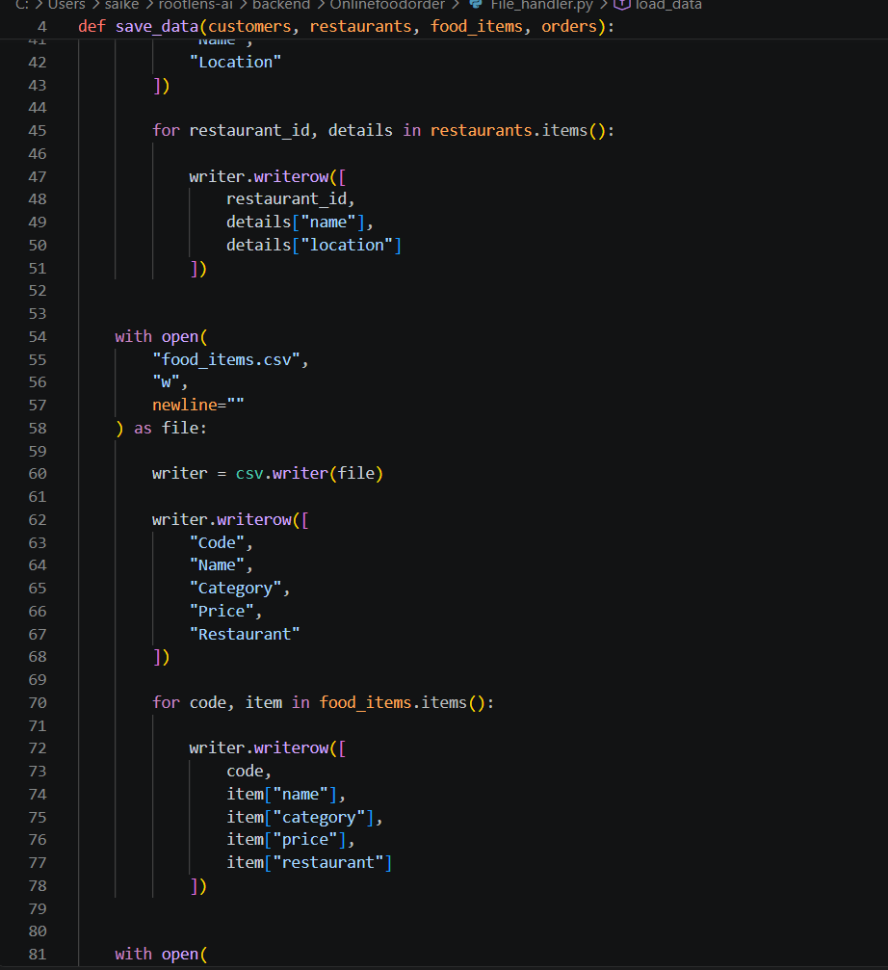
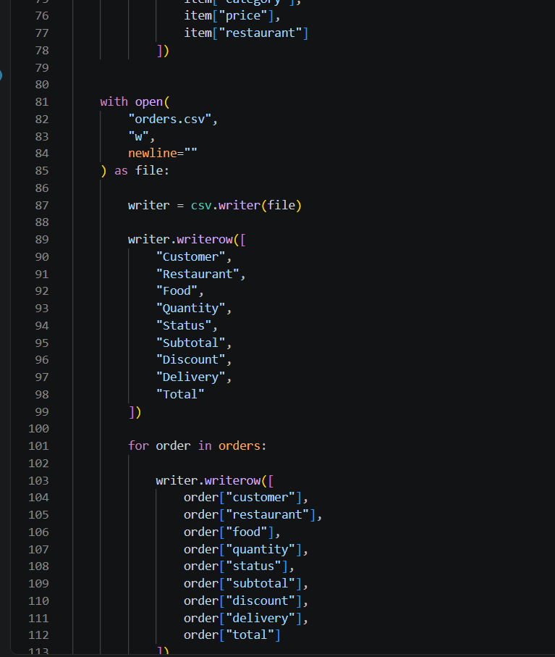
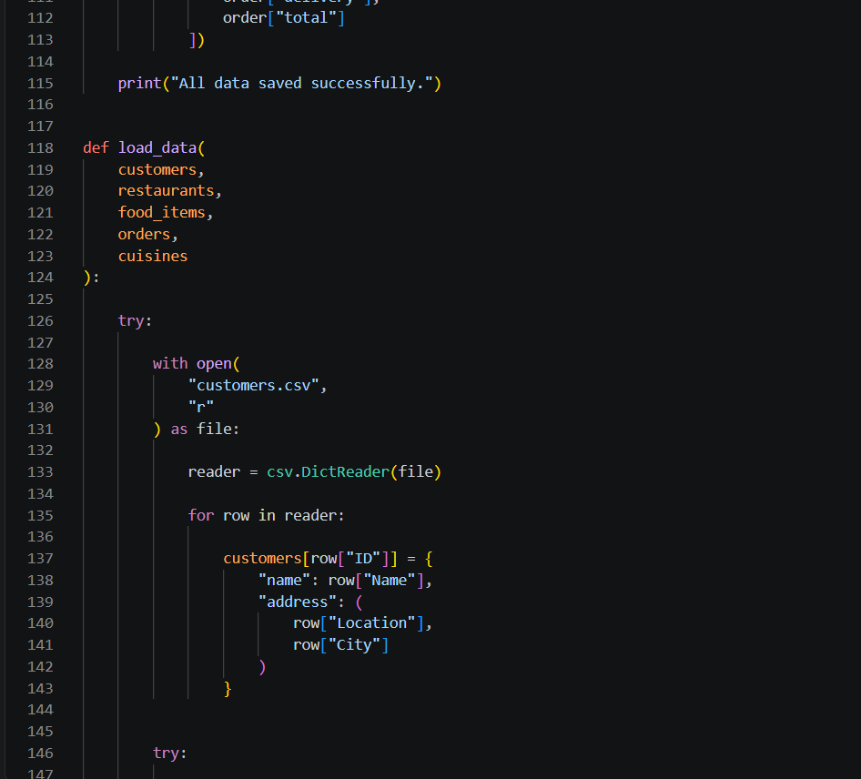
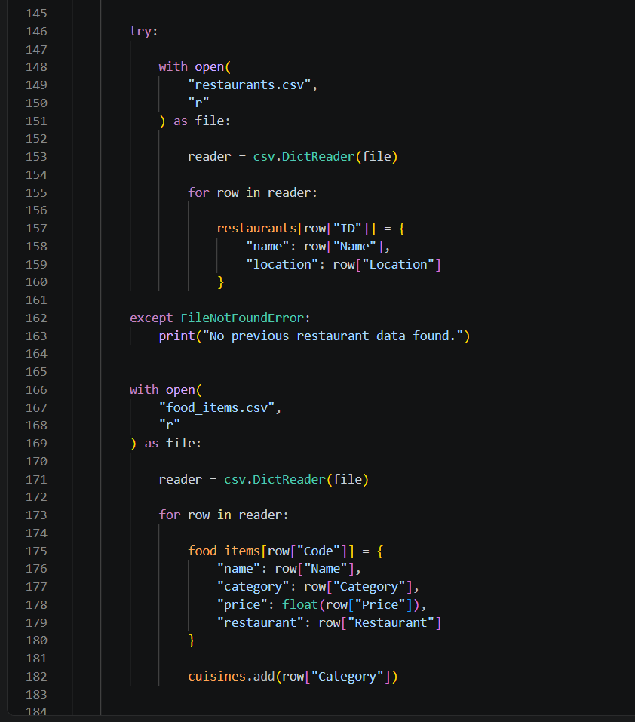
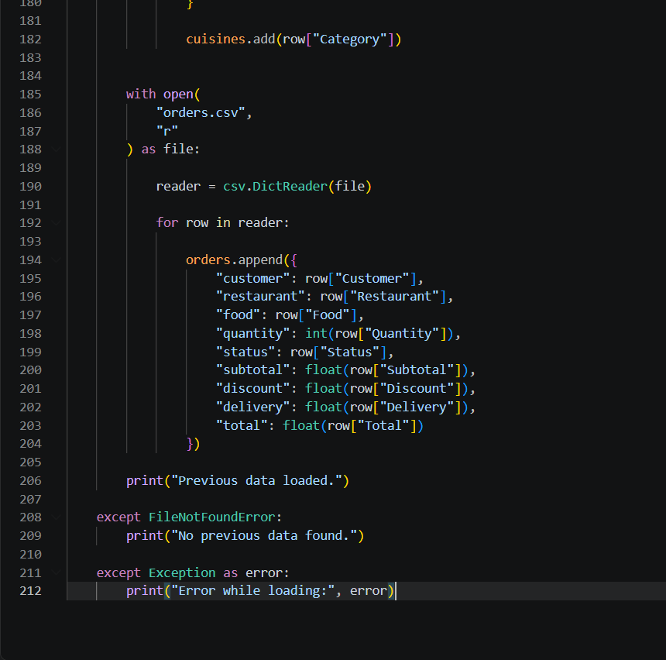
4.3 Test Plan & Verification
The verification matrix is derived from the implemented code paths shown in the supplied source screenshots. Status indicates code-level functional verification and does not claim independent production validation.
Requirement / Specification | Test Method | Acceptance Criterion
Add customer | Enter unique ID and valid details | Record is added
Duplicate customer | Reuse existing ID | Duplicate is rejected
Search customer | Enter full/partial name | Matching records displayed
Add restaurant | Enter unique ID, name and location | Restaurant is stored
Add food item | Enter valid code, category and positive price | Food record stored
Invalid price | Enter non-numeric or non-positive price | Validation prevents invalid record
Create order | Use valid customer, food and positive quantity | Order stored with calculated values
Discount boundary | Test subtotal below 500, 500–999.99 and 1000+ | Correct discount rule selected
Invalid quantity | Enter zero, negative or non-integer | OrderError handled
Change status | Enter valid and invalid statuses | Only valid statuses accepted
Customer value | Select existing customer | Matching order totals are summed
Compare orders | Select two valid order numbers | Higher/equal total reported
Generate report | Run report with stored records | Summary is displayed
Save/load | Save data and reload CSVs | Supported records reconstructed
4.4 Results
The implementation covers the principal assignment workflow: menu-driven navigation, record creation and search, order calculations, status updates, custom analysis, report generation and CSV persistence. The supplied evidence consists of source-code screenshots; separate runtime-output screenshots and measured performance data were not supplied, so no unprovided execution metrics are claimed.
4.5 Data Analysis & Engineering Judgment
The order calculation is deterministic: subtotal equals price multiplied by quantity; the discount is selected from subtotal thresholds; and the fixed delivery charge is added to obtain the total. This makes the result easy to explain and verify.
The use of different data structures follows the information requirement. Dictionaries support key-based lookup, the order list stores multiple orders, the address tuple represents fixed location information, and the cuisine set prevents duplicate categories. This provides a direct mapping between the problem and the Python course outcomes.
4.6 Comparison with Existing Solutions & Achievement of Objectives
Objective | Evidence | Achievement
Menu-driven workflow | main.py menu and dispatch logic | Fully Achieved
Customer management | customer.py add/search functions | Fully Achieved
Restaurant management | restaurant.py functions in supplied screenshots | Fully Achieved
Food and cuisine management | food.py functions | Fully Achieved
Order creation and update | order.py functions | Fully Achieved
Analysis | analysis.py customer value and comparison | Fully Achieved
Reporting | report.py aggregation functions | Fully Achieved
Persistence | file_handler.py CSV functions | Fully Achieved
Required data structures | Dictionary, list, tuple and set usage | Fully Achieved
4.7 Strengths & Limitations
Strengths
• Modular separation of responsibilities.
• Direct demonstration of list, tuple, dictionary and set structures.
• Input validation and custom OrderError handling.
• Deterministic order calculations.
• Custom analysis operations.
• Local CSV persistence without external server setup.
Limitations
• Console-only interface.
• CSV is not suitable for high-concurrency workloads.
• No live payment, delivery tracking or external API.
• Local CSV data is not encrypted.
• No independently recorded performance benchmark was supplied.
4.8 Project Planning, Roles & Budget
The project was completed as an individual assignment. The work sequence followed the dependency of the system: requirements and data structures → customer and restaurant management → food management → order processing → analysis and reporting → persistence → verification and documentation.
Phase | Activity | Outcome
1 | Understand assignment requirements and rubric | Workflow identified
2 | Design data structures and menu | Main structure established
3 | Implement customer/restaurant modules | Record management
4 | Implement food/order modules | Ordering workflow
5 | Implement analysis/report/persistence | Custom operations and storage
6 | Verification/documentation | Report evidence completed
Student | Assigned Responsibility | Actual Contribution
Keerthan M (1925260006) | Complete Python project | Design, implementation, integration, verification and documentation
Item | Estimated Cost | Actual Cost
Python / IDE / local file system | No additional cost | No additional cost
Documentation software | Existing resource | Existing resource
Total | No additional project expenditure | No additional project expenditure

CHAPTER 5
CONCLUSION, FUTURE WORK AND REFLECTION
5.1 Conclusion
The Online Food Order Management and Analysis System provides a modular Python implementation of a practical food-delivery workflow. It manages customers, restaurants, food items and orders through menu-driven operations and uses dictionaries, lists, tuples and sets according to the nature of the data.
The order workflow calculates subtotal, applies threshold-based discounts, adds the fixed delivery charge and stores the total. Analysis functions provide customer order-value calculation and order comparison, while reporting summarises sales, statuses and cuisine categories. CSV handling provides persistence. Within the academic scope, the system demonstrates the required Python concepts and provides a clear foundation for future extension.
5.2 Future Work
• Introduce SQLite or a server database for larger datasets.
• Add authentication and role-based access.
• Encrypt sensitive data and implement secure backup/recovery.
• Develop graphical, web or mobile interfaces.
• Integrate payment processing and notifications.
• Add live delivery tracking and delivery-agent management.
• Introduce richer analytics such as restaurant rankings and time-based sales trends.
• Add automated unit tests and continuous integration through GitHub.
5.3 Professional Learning & Individual Reflection
New Knowledge Acquired
• Using dictionaries, lists, tuples and sets for different data requirements.
• Separating a Python application into modules.
• Using custom exceptions and input validation.
• Using csv.writer and csv.DictReader for persistence.
• Building reusable analysis functions.
Engineering & Professional Skills Developed
• Requirement interpretation and system decomposition.
• Modular software design and integration.
• Debugging and code-level verification.
• Data modelling and algorithmic thinking.
• Technical documentation and evidence-based reporting.
Individual Reflection
The most difficult engineering problem was maintaining consistency between customer, food and order information while separating the application into modules. I addressed this by passing shared data structures to focused functions and validating identifiers before order creation.
A key design decision was to select data structures according to their purpose. Dictionaries provide direct lookup, the order list stores multiple records, the address tuple represents fixed location information, and the cuisine set prevents duplicates. This made the implementation easier to understand.
I strengthened my understanding of CSV persistence, custom exception handling and reusable functions. If the project were repeated, I would introduce automated unit tests and a database layer earlier to improve maintainability and scalability.

REFERENCES
[1] Python Software Foundation, “Python 3 Documentation.”
[2] Python Software Foundation, “csv — CSV File Reading and Writing,” Python Standard Library Documentation.
[3] Python Software Foundation, “Built-in Types,” Python Language Documentation.
[4] Python Enhancement Proposals, “PEP 8 – Style Guide for Python Code.”
[5] Department of Computer Science and Engineering, “CSA0801 – Python Programming: Assignment Questions and Assessment Rubrics,” 2026.
[6] Saveetha Institute of Medical and Technical Sciences, “Capstone Project Report – New Format – September 2026.”
[7] Online Food Order Management and Analysis System, project source-code screenshots supplied for assignment documentation, 2026.

APPENDICES
Appendix A – Detailed Calculations
Subtotal = Food Price × Quantity
If Subtotal ≥ Rs. 1000: Discount = 10% of Subtotal
Else if Subtotal ≥ Rs. 500: Discount = 5% of Subtotal
Else: Discount = Rs. 0
Delivery Charge = Rs. 40
Total = Subtotal − Discount + Delivery Charge
Example: For a subtotal of Rs. 1000, discount = Rs. 100 and total = Rs. 940.
Appendix B – Engineering Drawings / Schematics

Online Food Order Management System Architecture
Appendix C – Source Code / Code Repository Information
The complete source-code evidence is included in Chapter 4 as original screenshots arranged by module. The modules are main.py, customer.py, restaurant.py, food.py, order.py, analysis.py, report.py and file_handler.py. A GitHub repository URL was not supplied in the source materials, so no repository address is invented here. The repository link should be inserted before final submission if required.
Appendix D – Datasheets
Not applicable. This is a software-only Python prototype.
Appendix E – Experimental / Raw Data
No separate raw measurement dataset was supplied. Verification is based on implemented program logic and source-code evidence.
Appendix F – Ethics / Institutional Approval
No institutional approval is required for this academic software prototype. Ethical considerations include responsible handling of customer information, transparent billing rules and acknowledgement of security limitations.
Appendix G – Project Meeting / Progress Records
Individual assignment; formal team meeting records are not applicable.
Appendix H – User / Industry Feedback
No external user or industry feedback was supplied in the source materials.
Appendix I – Publications / Patents / Competitions / Product Outcomes
Not applicable to this assignment prototype.
Appendix J – Individual Contribution Evidence
Keerthan M (1925260006) completed the project as an individual assignment. The front-matter contribution statement records 100% contribution covering design, development, testing, analysis and report preparation.

